**Software document**

**Author:** Maxime Cardinal

**Date:** October 30th, 2018

**Version:** 5.1

**Edit history:** [Version system is WEEK#.EDIT#]

October 30, 2018 - Maxime Cardinal - Creation of the document, preliminary content - 2.1

October 30, 2018 - Spencer Handfield - Adjusted formatting for consistency with other docs and added table of contents - 2.2

November 5, 2018 - Maxime Cardinal - Modification of TravelToTree class description, Addition of the TravelToTree and travelToBridge flowcharts - 3.1

November 5, 2018 - Spencer Handfield - Elaboration of findings and design flow/logic of certain classes - 3.2

November 5, 2018 - Irmak Pakis - Added to OdometerCorrection - 3.3

November 6, 2018 - Spencer Handfield - Reformatted certain section to attempt to better illustrate the week by week design process logic - 3.4

November 11, 2018 - Spencer Handfield - Addition of week 4 implementation/modification of software - 4.1

November 13, 2018 - Spencer Handfield - modified section to reflect project description v2.0 - 4.2

November 15, 2018 – Maxime Cardinal – Modification of classes and update of the software architecture due to beta demo results - 5.0

November 18, 2018 – Maxime cardinal – Addition of flow charts for classes and further explanation of the Wifi class - 5.1

**1.0 Table of contents**

2.0 Functionality

3.0 Classes

3.1 DesignProjectMain (add flow chart)

3.2 OdometerData (ok)

3.3 Odometer (ok)

3.4 OdometerExceptions (ok)

3.5 Wifi (ok)

3.6 Localization (ok)

3.6.1 usLocalization() (ok)

3.6.2 lsLocalization() (ok)

3.7 TravelToTree

3.8 RingRetrieval (ok)

3.8.1 reachRingSet() (ok)

3.8.2 ringGrab() (ok)

3.8.3 colorIdentification() (ok)

3.9 TravelBack

3.10 RingUnload

3.11 Class Diagram

4.0 Progress and decision explanation

5.0 Improvements

6.0 Glossary of terms

**2.0 Functionality**

The robot must execute many independent tasks to reach its goal. First, the robot must receive the competition parameters via Wifi and localize itself in the grid. Then, it must travel to the tunnel, cross that tunnel and reach for its team corresponding tree, while correcting its position. Afterward, it must retrieve one or many rings and identify their corresponding color. Finally, the robot must travel back to its original position via the tunnel and unload the ring(s) it retrieved (see Figure 1).

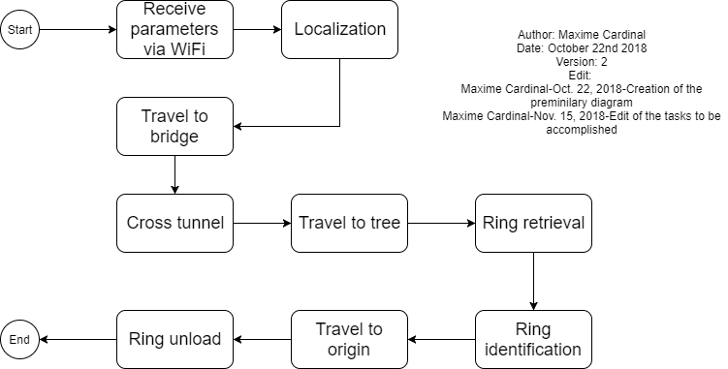

Figure 1 - Functionality flow chart

The following pages further explain how those tasks are executed by the software and what classes are responsible for handling those tasks.

**3.0 Classes**

**3.1 DesignProjectMain**

The “DesignProjectMain” class is the main class of the project. It is responsible for launching the program, initializing all the sensors, all the motors and the important constants. Also, this class is responsible for starting required threads and calling required method from other classes. We decided to initialize all sensors and motors in this class to minimize our time consumption when starting new threads. Furthermore, by calling methods from other classes instead of creating threads, we minimized the number of threads required thus reducing the chances of program failure due to overhead.

//To be added: flowchart of the class -> will be added once software is completed

**3.2 OdometerData**

The “OdometerData” class is responsible of keeping track of the robot’s location and orientation. It stores and provides a save access to the odometer data. It contains methods such as “getXYT()”, “update(double dx, double dy, double dtheta)”, “setXYT(double x, double y, double theta)”, “setX(double x)”, “setY(double y)” and “setTheta(double theta)”, which can be used to access odometer data easily. This class has been reused from previous lab.

**3.3 Odometer**

The “Odometer” class is responsible of updating the odometer data according to the robot’s wheels displacement. This class extends the “OdometerData” class and has been reused from the previous lab we did. The “Odometer” class is running as a thread by the main class “DesignProjectMain” and runs until the end of the whole program.

**3.4 OdometerExceptions**

The “OdometerExceptions” class is used to handle errors regarding the singleton pattern used for the odometer and “OdometerData”. This class has been reused from the previous lab and was provided to us.

**3.5 Wifi**

The “Wifi” class is responsible for connecting the EV3 brick to a server, receiving the game parameters and assigning the required game parameters depending on the team’s color. The “Wifi” class make use of an imported library to create a WifiConnection and receive the data from the server. Both the class and the library were provided, but we had to change the Wifi class so that it only assigns the desired parameters to the project. The Wifi class first retrieves the data from the server, then compares the robot’s team number to each parameter team number (green/red) and assigns the parameters according to the team color (See Figure 2).

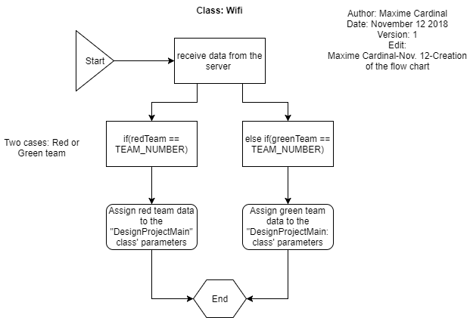

Figure 2 - Wifi class flow chart

**3.6 Localization**

The “Localization” class is responsible of correcting the initial position and the orientation of the robot to be (0,0) and 0-degree respectively. This class has been implemented using the class “UltrasonicLocalizer” and “LightLocalizer” from Lab5. The “UltrasonicLocalizer” class was responsible of correcting the robot orientation, making use of an ultrasonic sensor and the “LightLocalizer” class was responsible of correcting the initial position of the robot making use of a light sensor. We decided to merge these two classes into one to minimize the time consumption of the process. By merging these classes, we reduce the number of classes needed by one, thus reducing the time needed to initialize sensors, variables and constants. The code has been further simplified to increase its readability by making use of multiple methods. This class contains is separated into two main methods: usLocalization() and lsLocalization().

**3.6.1 usLocalization()**

The “usLocalization()” method is responsible for correcting the initial angle of the robot in the grid. To do so, this method makes use of an ultrasonic sensor to detect its position relative to the walls. Using a falling edge algorithm, the robot will compute the angle difference between the left and right falling edge to determine its orientation in the grid (see Figure 3).

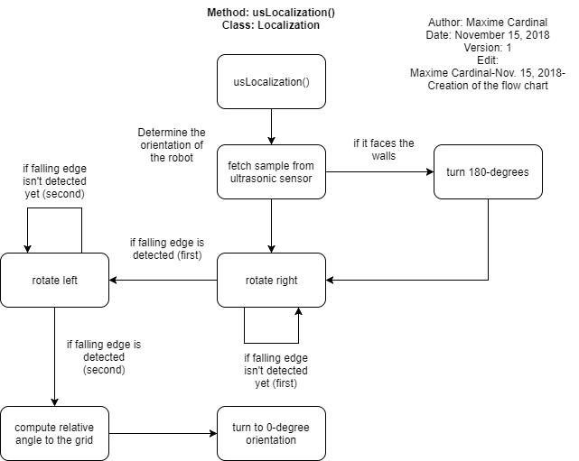

Figure 3 - usLocalization Flow Chart

To filter the sensor samples, we restrained the falling edge detection to be from 0 to 40 cm, thus reducing the probability of detecting false falling edge at long distances. Since falling edge implementation requires the robot to be facing the outside of its starting corner, the sensor first detects if it is facing the good direction or not. If not, it will perform a 180-degree rotation before starting the falling edge detection (see Figure 4).

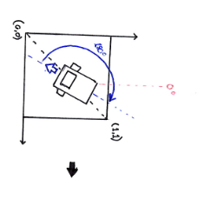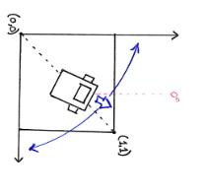

Figure 4 - Falling edge: Starting orientation correction

**3.6.1 lsLocalization()**

The “lsLocalization()” method is responsible for correcting the initial position of the robot to its closest grid intersection. To facilitate the understanding, the starting corner of the robot will be defined as 0 and its closest grid intersection will be defined as (1,1) for the following explanations. To correct the robot’s position, we used to only use one light sensor. At first, the light sensor localization algorithm was simple: the robot moved straight forward until it detected a line with the left light sensor, then it turned 90-degrees right and repeated the same process to correct its position to be (1,1) (see Figure 5).

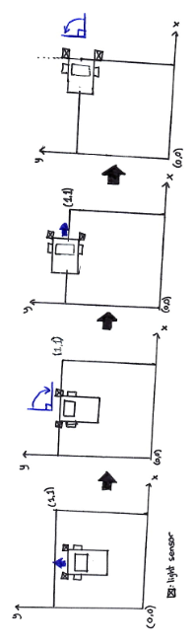

Figure 5 - initial light sensor localization algorithm

After review, it was concluded that this algorithm wasn’t a reliable position correction, as the its totally depends on the ultrasonic localization accuracy. An offset in the ultrasonic localization would directly impacts the precision of this method, which is an undesirable effect and had to be corrected. Thereby, we came up with our second light sensor localization, which made use of two light sensors and a more complex algorithm. Instead of assuming the orientation of the robot is good when crossing the lines, the robot makes use of the light sensors to correct its orientation again. The algorithm goes as follow: The robot moves forward until one of the sensors detects a line. Then, it stops the left or right motor according to the sensor that detected the line. Finally, it turns until the second sensor detects the line (see Figure 6).

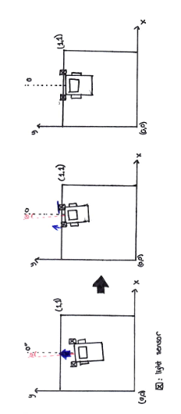

Figure 6 - Second light sensor localization algorithm

This light sensor localization ensures that the final position and orientation of the robot after executing the localization are respectively (1,1) and 0-degree (see Figure 7).

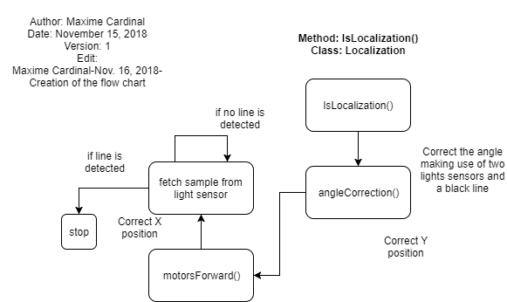

Figure 7 - lsLocalization Flow Chart

**3.8 RingRetrieval**

The “RingRetrieval” class contains the methods responsible of retrieving a ring from the tree, identifying the color of the ring and unloading the ring. To implement this class, we made use of methods and constants from the ring identification class of Lab5.  It requires a light sensor, which will identify the ring color, and two large EV3 motor, which control the claws for the ring retrieval. This class is separated in four main methods: reachRingSet(), ringGrab(), colorIdentification() and ringUnloading().

**3.8.1 reachRingSet()**

The “reachRingSet()” method is responsible for opening the robot’s arm to prepare it for ring retrieval and forwarding the robot to the desired retrieval distance from the tree (See Figure 8).

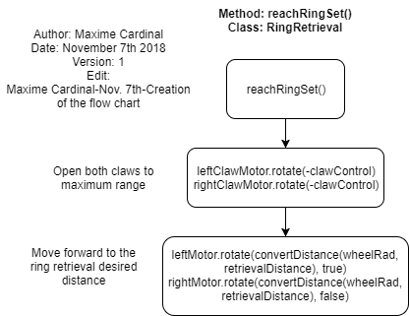

Figure 8 - reachRingSet() flow chart

**3.8.2 ringGrab()**

The “ringGrab” method is responsible for closing the claws to the required angle for the ring retrieval and moving the robot backward to the closest grid intersection. While doing so, the robot retrieves the ring from the tree as it is restrained by the claws. The following flow chart describes the algorithm of the method (See Figure 9).

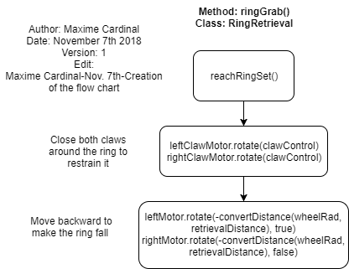

Figure 9 - ringGrab() flow chart

**3.8.3 colorIdentification()**

The “colorIdentification” method is responsible for identifying the retrieved ring’s color, by making use of a light sensor. This method’s implementation was easy, as it was already implemented during the Lab 5 (See Figure 10). We made use of normalization when identifying the ring’s color, as it is a more suitable algorithm for the method. With normalization of the samples, the color identification is independent of the lighting, thus offers more capabilities to the robot.

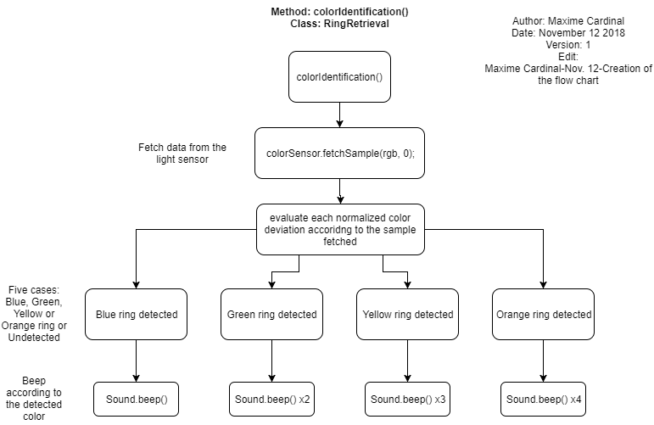

Figure 10 - colorIdentification() flow chart

**3.8.4 ringUnloading()**